**RRJETAT E KOMPJUTERAVE 1**

**LAB 8**

**Tema:** Konfigurimi i NAT (Network Address Translation) dhe PAT (Port Address Translation)

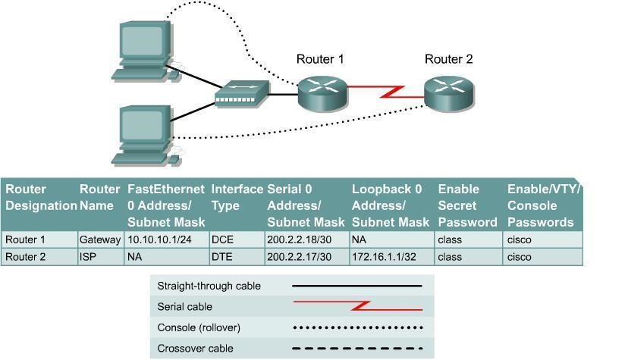

# Step 1 Configure the routers

Configure all of the following according to the chart:

* The hostname
* The console
* The virtual terminal
* The enable passwords
* The interfaces

If problems occur during this configuration, refer to Lab 1.1.4a Configuring NAT.

# Step 2 Save the configuration

At the privileged EXEC mode prompt, on both routers, type the command **copy running-config** **startup-config**.

# Step 3 Configure the hosts with the proper IP address, subnet mask, and default gateway

Each workstation should be able to ping the attached router. If for some reason this is not the case, troubleshoot as necessary. Check and verify that the workstation has been assigned a specific IP address and default gateway. If running Windows 98, check using **Start** > **Run** > **winipcfg**. If running Windows 2000 or higher, check using **ipconfig** in a DOS window.

# Step 4 Verify that the network is functioning

1. From the attached hosts, ping the FastEthernet interface of the default gateway router.

1. Was the ping from the first host successful?

______________________________________

1. Was the ping from the second host successful?

___________________________________

1. If the answer is no for either question, troubleshoot the router and host configurations to find the error. Then ping again until they both are successful.

# Step 5 Create a static route

a. Create a static route from the ISP to the Gateway router. Addresses 199.99.9.32/27 have been allocated for Internet access outside of the company. Use the **ip route** command to create the static route.

# ISP(config)#ip route 199.99.9.32 255.255.224.0 200.2.2.18

1. Is the static route in the routing table?

___________________________________________

1. What command checks the routing table contents?

_________________________________

1. If the route was not in the routing table, give one reason why this might be so? ________________________________________________________________

# Step 6 Create a default route

a. Add a default route, using the **ip route** command, from the Gateway router to the ISP router.

This will forward any unknown destination address traffic to the ISP:

# Gateway(config)#ip route 0.0.0.0 0.0.0.0 200.2.2.17

1. Is the static route in the routing table?

___________________________________________

1. Try to ping from one of the workstations to the ISP serial interface IP address.

1. Was the ping successful?

____________________________________________________

1. Why?

_______________________________________________________________

**Step 7 Define the pool of usable public IP addresses**

To define the pool of public addresses, use the **ip nat pool** command:

Gateway(config)#**ip nat pool public-access 199.99.9.32 199.99.9.35** **netmask 255.255.255.252**

# Step 8 Define an access list that will match the inside private IP addresses

To define the access list to match the inside private addresses, use the **access list** command:

Gateway(config)#**access-list 1 permit 10.10.10.0 0.0.0.255**

**Step 9 Define the NAT translation from inside list to outside pool**

To define the NAT translation, use the **ip nat inside source** command:

Gateway(config)#**ip nat inside source list 1 pool public-access overload**

# Step 10 Specify the interfaces

The active interfaces on the router need to be identified as either inside or outside interfaces with respect to NAT. To do this, use the **ip nat inside** or **ip nat outside** command:

# Gateway(config)#interface fastethernet 0

Gateway(config-if)#**ip nat inside**

Gateway(config-if)#**interface serial 0**

Gateway(config-if)#**ip nat outside**

# Step 11 Testing the configuration

1. From the workstations, **ping 172.16.1.1**. Open multiple DOS windows on each workstation and Telnet to the 172.16.1.1 address. Next, view the NAT translations on the

Gateway router, with the command **show ip nat translations**.

1. What is the translation of the inside local host addresses?

______________ = _____________ ______________ = ________________

# Step 12 Verify NAT and PAT Statistics

1. To view the NAT and PAT statistics type the **show ip nat statistics** command at the privileged EXEC mode prompt.

1. How many active translations have taken place?

___________________________________

1. How many addresses are in the pool?

__________________________________________

1. How many addresses have been allocated so far?

_________________________________

Upon completion of the previous steps finish the lab by doing the following:

* + Logoff by typing **exit**
  + Turn the router off
  + Remove and store the cables and adapter

Step 1:

Konfigurojmë sipas kërkesës.Ne fund këto janë rezultatet:

Step 3:

Step 4:

Bejmë ping prej cdo hosti tek default gateway.

Step 5:

Krijojme static route.

Rruga Statike ndodhet ne tabelën e shfaqur me ane të show ip route.

Step 6:

Krijojme nje default route

Rruga ndodhet ne tabele.

Të gjitha ping ishin të suksesshme.

Step 7 , 8 ,9:

Step 10:

Step 11:

Përkthimi është i tillë:

Inside => 10.10.10.2 = 199.99.9.33

Outside => 172.16.1.1= 172.16.1.1

Step 12:

Kemi 4 adresa totale, 1 te alokuar dhe gjithsej kemi 15 përkthime aktive.

